**TASK-2**

**Project Title: Student Database Management System**

**PostgreSQL**

**1.Database Setup**

**Create a database named "student_database"**

CREATE DATABASE student_database;

**Create a table called "student_table " with the following columns: Student_id (integer), Stu_name (text), Department (text), email_ id (text ),Phone_no (numeric), Address (text), Date_of_birth (date), Gender (text), Major (text), GPA (numeric),Grade (text) should be A,B,C etc.**

CREATE TABLE student_table (

Student_id INTEGER,

Stu_name TEXT,

Department TEXT,

email_id TEXT,

Phone_no NUMERIC,

Address TEXT,

Date_of_birth DATE,

Gender TEXT,

Major TEXT,

GPA NUMERIC,

Grade TEXT

);

**2.Data Entry**

**Insert 10 sample records into the "student_table" using INSERT command.**

INSERT INTO student_table (Student_id, Stu_name, Department, email_id, Phone_no, Address, Date_of_birth, Gender, Major, GPA, Grade)

VALUES

(1, 'John Doe', 'Computer Science', 'john.doe@example.com', 1234567890, '123 Main St', '1998-05-15', 'Male', 'Computer Science', 3.75, 'A'),

(2, 'Jane Smith', 'Mathematics', 'jane.smith@example.com', 9876543210, '456 Elm St', '1999-02-28', 'Female', 'Mathematics', 3.9, 'A'),

(3, 'Michael Johnson', 'Physics', 'michael.johnson@example.com', 5551234567, '789 Oak Ave', '1997-11-10', 'Male', 'Physics', 3.2, 'B'),

(4, 'Emily Davis', 'Chemistry', 'emily.davis@example.com', 4447891234, '321 Pine Rd', '1998-09-22', 'Female', 'Chemistry', 3.6, 'A'),

(5, 'David Wilson', 'Biology', 'david.wilson@example.com', 6669998888, '567 Cedar Ln', '1999-07-07', 'Male', 'Biology', 3.8, 'A'),

(6, 'Sarah Brown', 'Psychology', 'sarah.brown@example.com', 2223334444, '987 Maple Ave', '1997-03-12', 'Female', 'Psychology', 3.4, 'B'),

(7, 'Christopher Lee', 'English', 'christopher.lee@example.com', 7778889999, '654 Walnut St', '1998-12-01', 'Male', 'English', 3.1, 'B'),

(8, 'Olivia Martinez', 'History', 'olivia.martinez@example.com', 1112223333, '876 Birch Rd', '1999-06-18', 'Female', 'History', 3.7, 'A'),

(9, 'Daniel Taylor', 'Economics', 'daniel.taylor@example.com', 9998887777, '543 Pine Ln', '1997-04-25', 'Male', 'Economics', 3.5, 'B'),

(10, 'Sophia Anderson', 'Sociology', 'sophia.anderson@example.com', 4445556666, '321 Elm Ave', '1998-08-08', 'Female', 'Sociology', 3.3, 'B');

**3.Student Information Retrieval**

**Develop a query to retrieve all students' information from the "student_table" and sort them in descending order by their grade**

SELECT *

FROM student_table

ORDER BY Grade DESC;

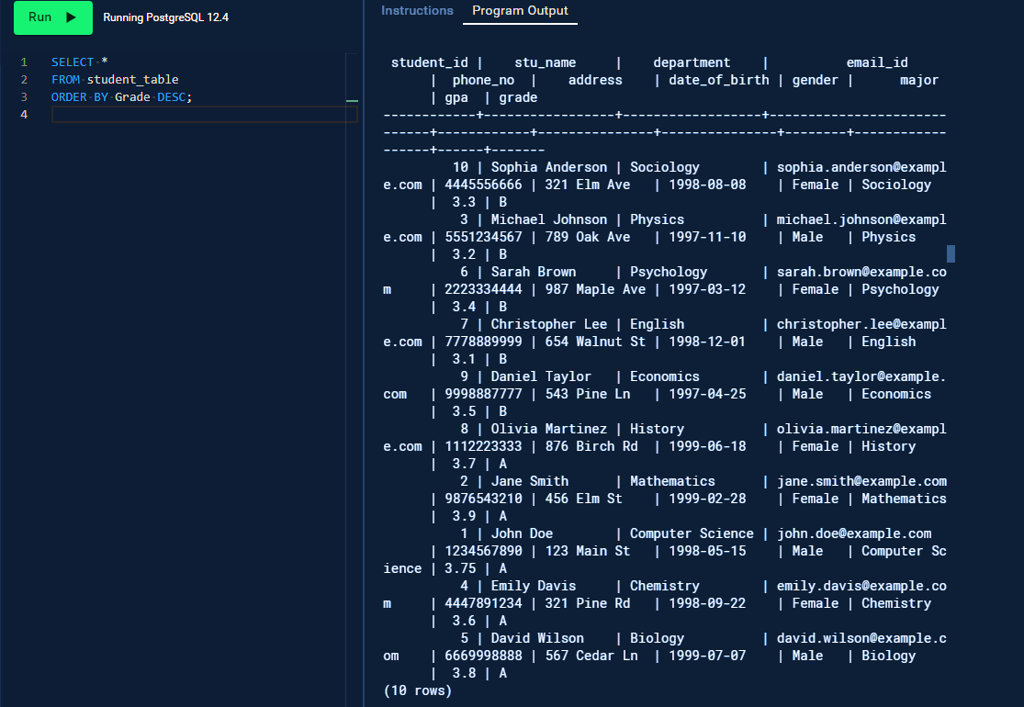

**4.Query for Male Students:**

**Implement a query to retrieve information about all male students from the "student_table"**

SELECT *

FROM student_table

WHERE Gender = 'Male';

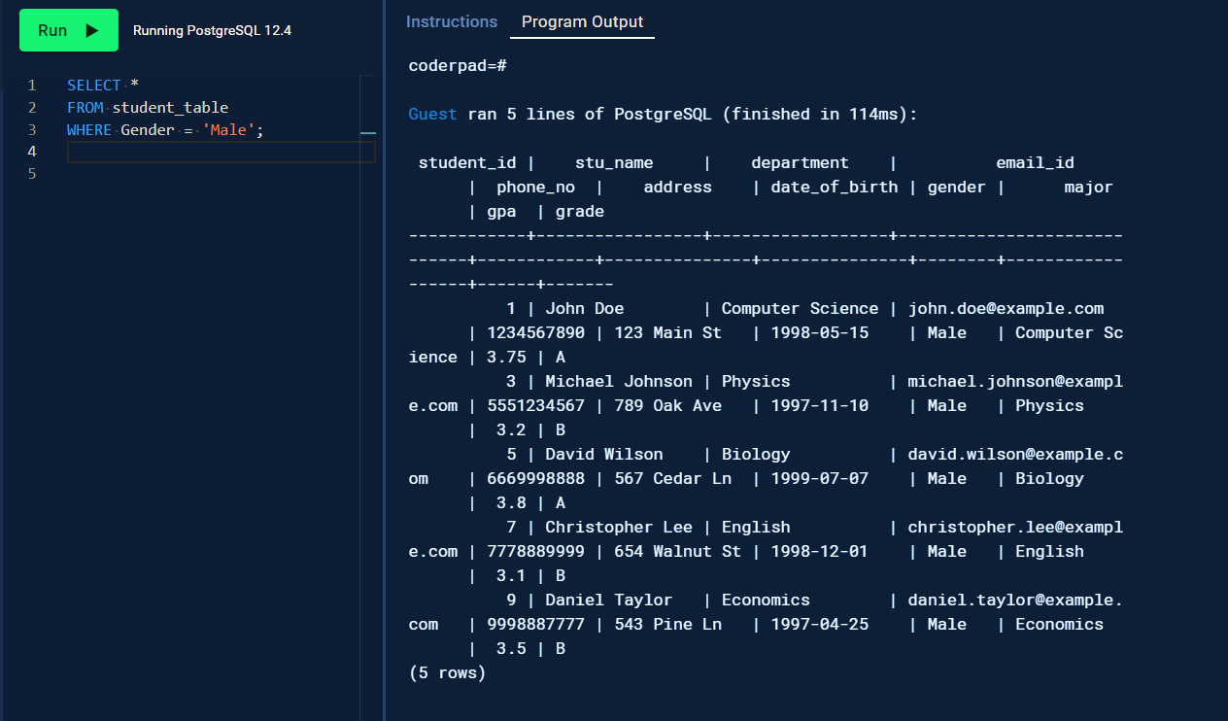

**5.Query for Students with GPA less than 5.0**

**Create a query to fetch the details of students who have a GPA less than 5.0 from the "student_table"**

SELECT *

FROM student_table

WHERE GPA < 5.0;

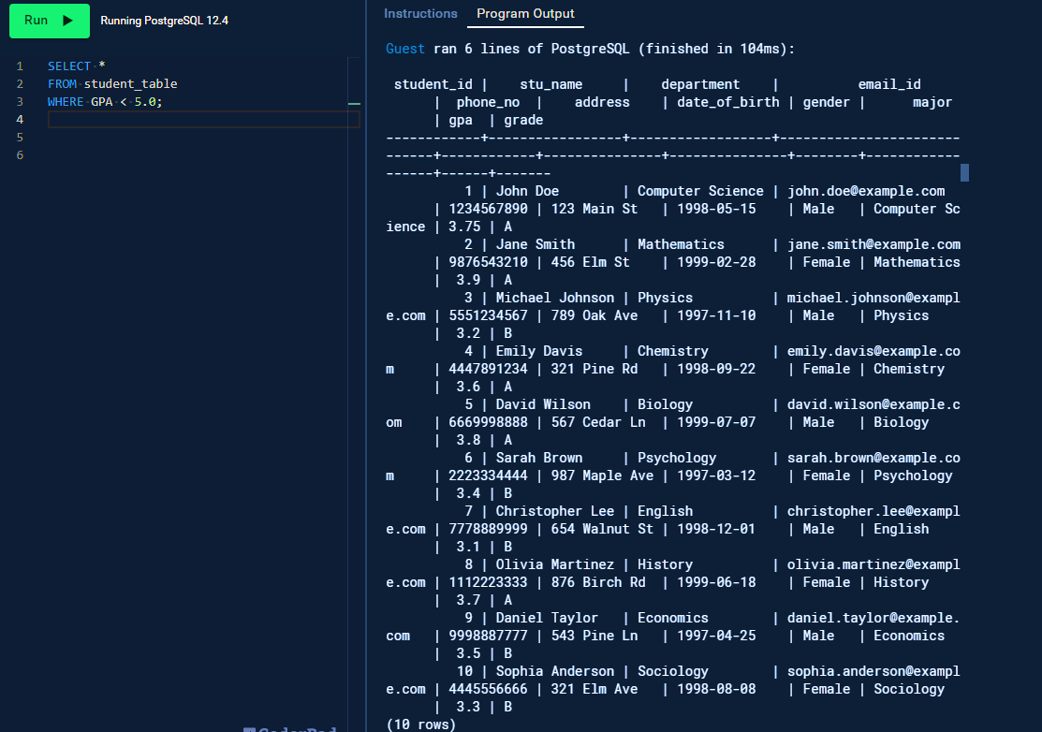

**6.Update Student Email and Grade**

**Write an update statement to modify the email and grade of a student with a specific ID in the**

**"student_table"**

UPDATE student_table

SET email_id = 'newemail@example.com',

Grade = 'A'

WHERE Student_id = 1;

**7.Query for Students with Grade "B"**

**Develop a query to retrieve the names and ages of all students who have a grade of "B" from the "student_table"**

SELECT Stu_name, DATE_PART('year', AGE(CURRENT_DATE, Date_of_birth)) AS Age

FROM student_table

WHERE Grade = 'B';

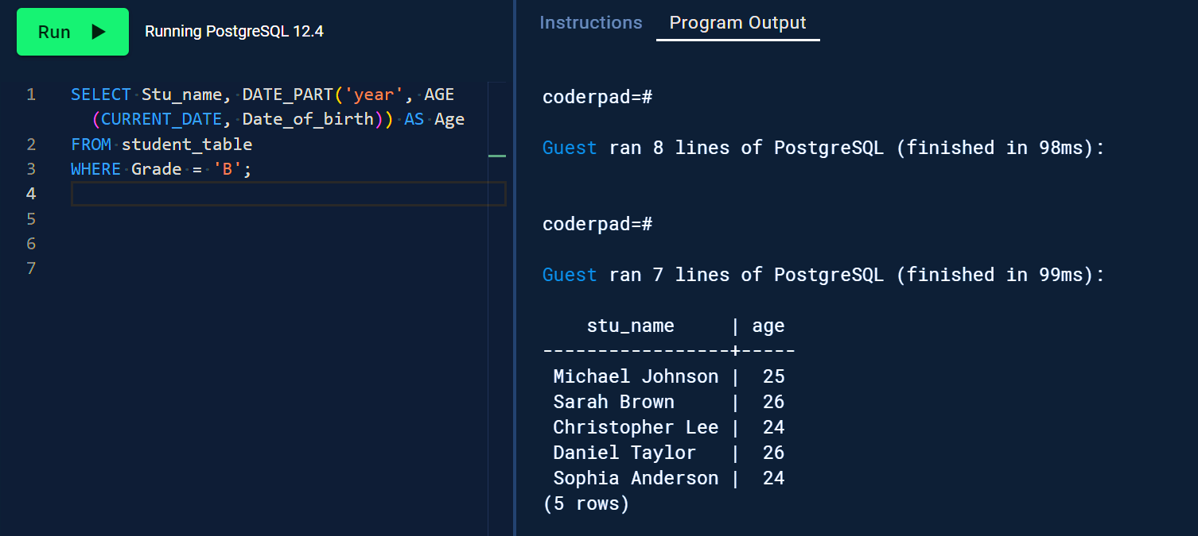

**8.Grouping and Calculation**

**Create a query to group the "student_table" by the "Department" and "Gender" columns and calculate the average GPA for each combination**

SELECT Department, Gender, AVG(GPA) AS Average_GPA

FROM student_table

GROUP BY Department, Gender;

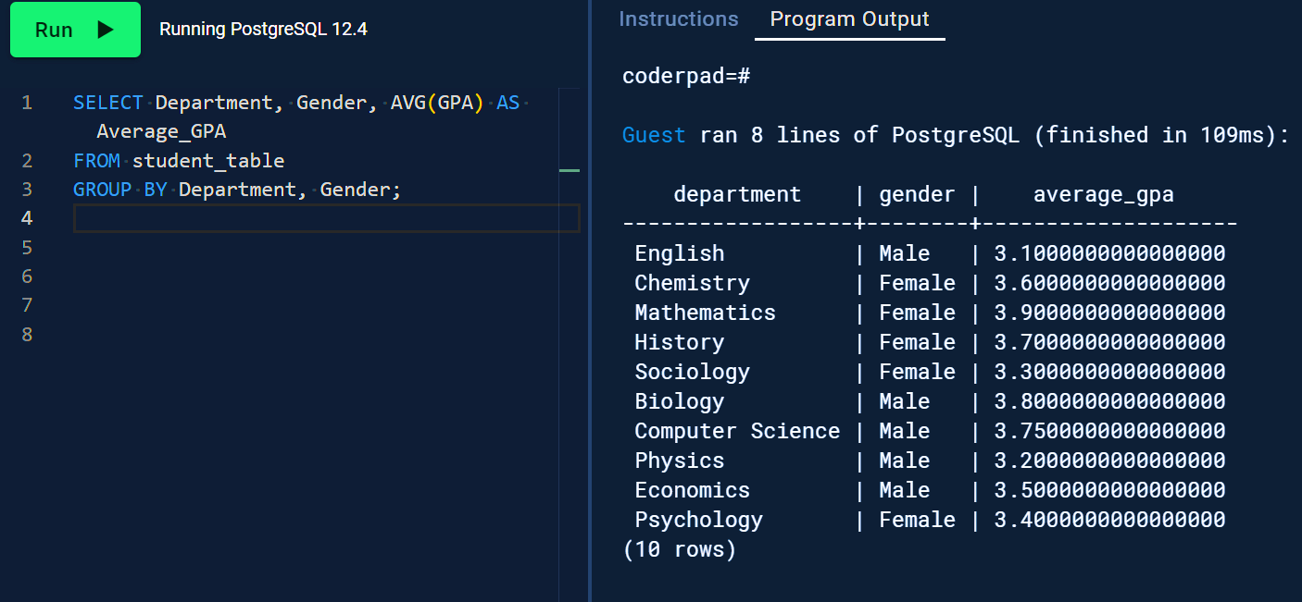

**9.Table Renaming**

**Rename the "student_table" to "student_ info" using the appropriate SQL statement.**

ALTER TABLE student_table

RENAME TO student_info;

**10.Retrieve Student with Highest GPA**

**Write a query to retrieve the name of the student with the highest GPA from the "student_ info" table.**

SELECT Stu_name

FROM student_info

WHERE GPA = (SELECT MAX(GPA) FROM student_info);

